AI LAB TASKS SUBMISSION DOCX. FILE
Submitted By : Ali Hassan Gill
Roll Number : 079
Section : BSAI-3B
Submitted To: Mr. Rasikh Ali

Problem Statement:

A rescue robot is required to search emergency exit graph without the use of any heuristics. In this graph the edged path is not necessarily the path which contains very low cost this lab involves the application of BFS, DFS, DLS , IDDFS, and UCS algorithms to locate an exit and subsequently comparing them based on their paths, and node-expansion behavior, and cost .

This lab consists of three parts:

Manual Tracing: Manually tracing BFS and DFS on an A–G graph.

Depth Iddfs: Implementing DLS and IDDFS. Testing them with depth limits ranging from 1, to 4.

Uniform Cost Search (UCS): Applying UCS to a version of the graph and comparing it with BFS.

Assumptions:
1. Node A is the starting location and Node G is the exit point.
2. When there is a tie in priority the order of list of successors will be used as a tie breaker.
3. Depth is measured by counting edges.so the root node A has a depth of 0.
4. All the edge weights represents the negative travel cost units And the Uniform Cost Search is only applicable when all costs are non negative.
5. The C to G corridor is included in the weighted graph. This is an extension, for the weighted experiment. Is not part of the original graph used in the manual trace
6. the expansion traces show the order in which nodes are expanded and the goal node is counted as having been processed.

State-Space Formulation:
Element Definition
Initial state Node A
Actions / successors Moving to a neighboring node via a corridor
Goal test Is the current node G
Path cost The number of edges (for BFS, DFS, DLS, IDDFS

Implementation Choices
Graph Structure: Python is,the graph is stored as a dictionary that contains lists of successors. The lists are kept in a fixed order so that the sanme trace is produced each time.
BFS: This algorithm uses a quue called `deque` and a set to keep track of nodes that have already been visited.
DFS: This algorithm uses a stack.neighbours are pushed onto the stack in order so that the first neighbour in the list is visited before the others.
Iddfs (lab3_depth_search.py): DLS checks for cycles only along the current path and returns one of three results FOUND , CUTOFF, or FAILURE, IDDFS repeetedly raises the depth limit and runs DLS again it does not share a set of visited nodes, between the runs.
UCS (lab3_ucs.py): This algorithm uses a prority queue called `heapq` which is ordered by the cost of path
Output: Every run shows the order in wihich nodes are processed by the path taken and the total cost

Task 01:
Manual Tracing of BFS and DFS Algorithms
BFS works with a queue. It checks nodes level, by level.DFS uses a stack. It goes first then backtracks.On the A to G graph BFS visits the nodes in this order: A B, C, D, E, F, G.
DFS visits them in this order: A B, D, E G.
Both algorithms find the path: A → B → E → G.

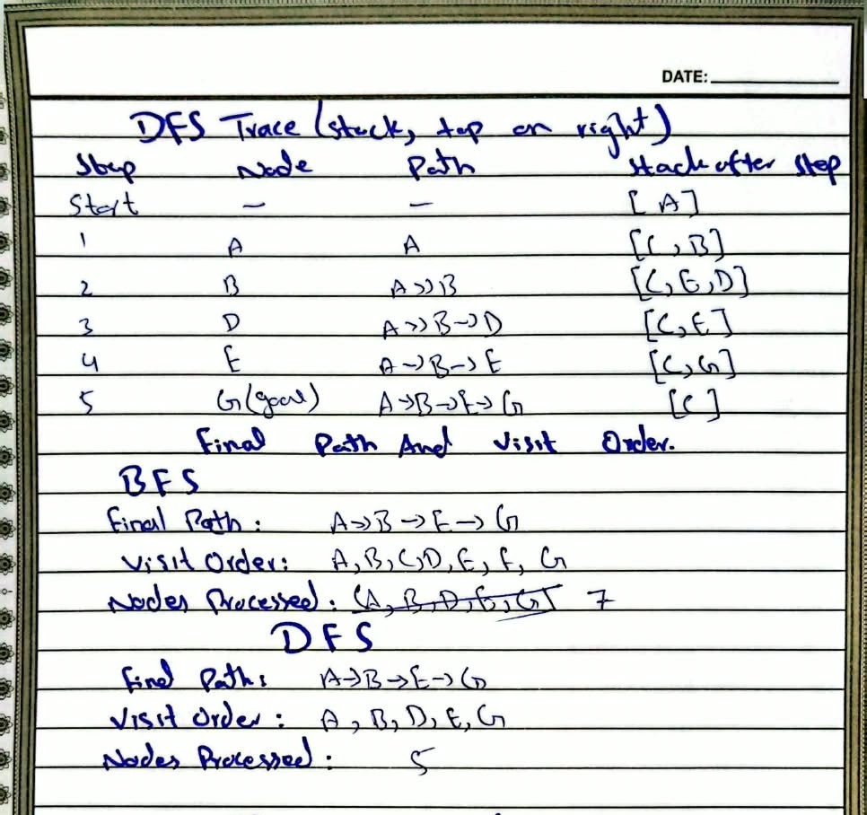

Task 02: DLS and IDDFS

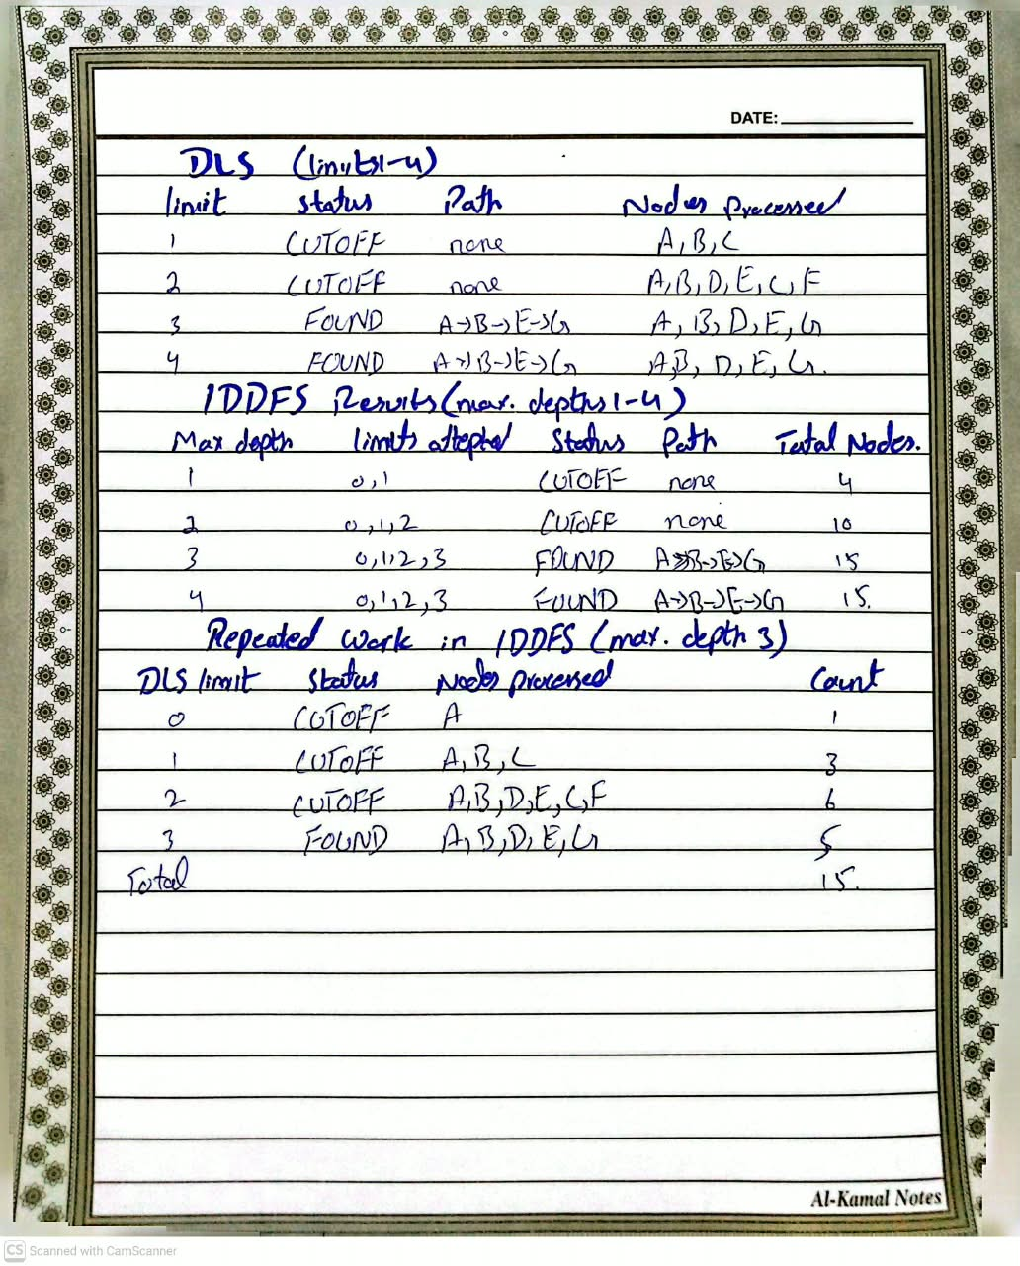

Task 03 : BFS on the Weighted Graph (compared with UCS)

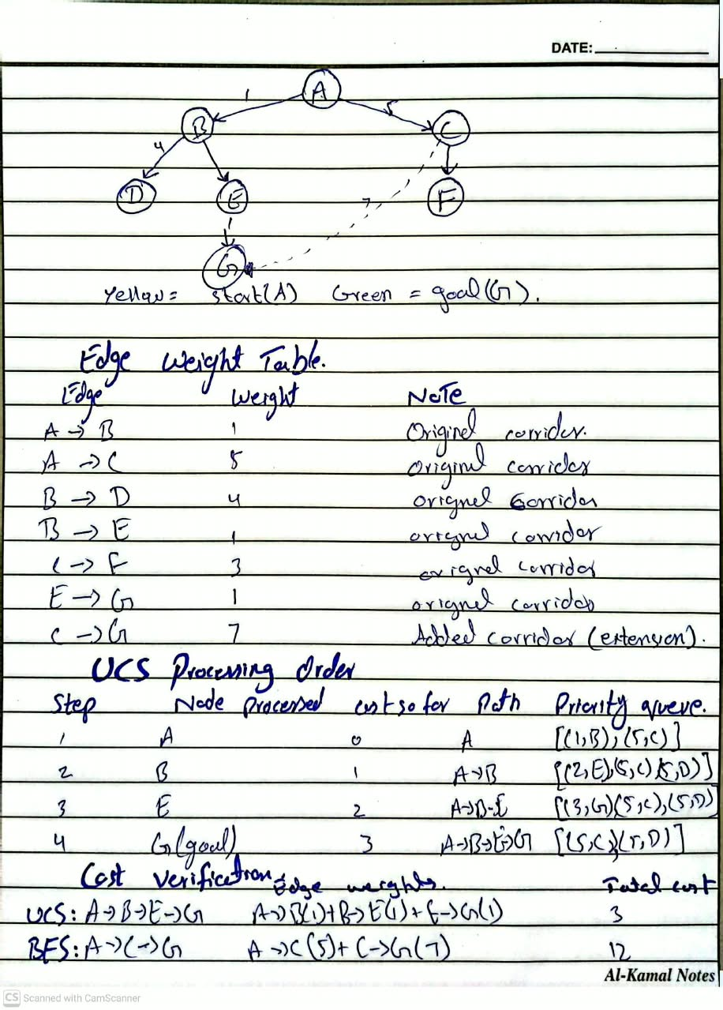

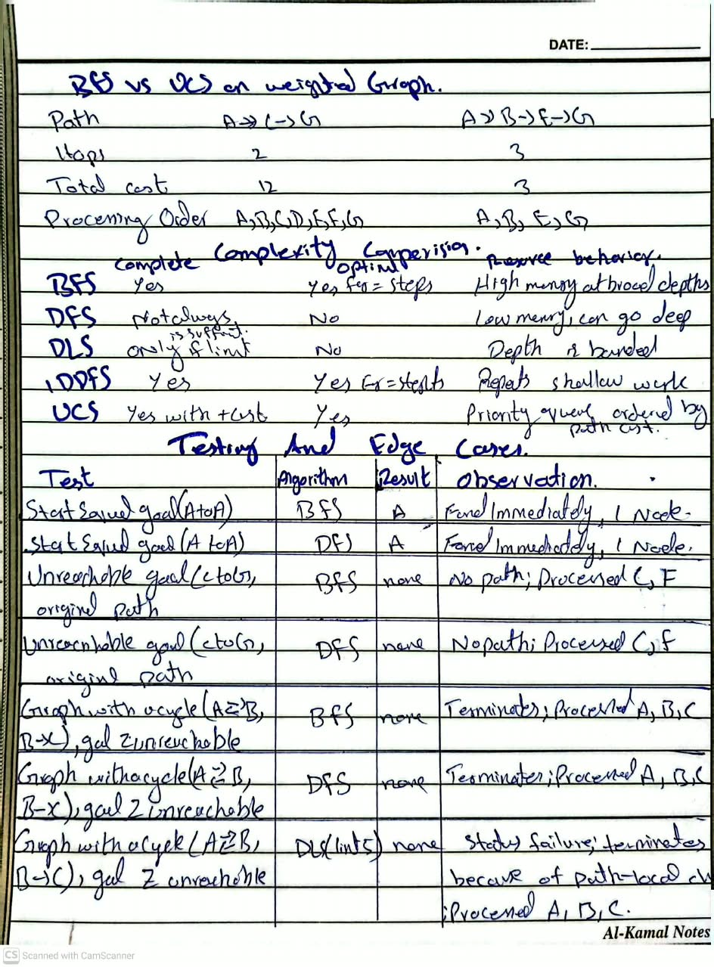

Complexity comparision :

Strategy | Complete | Optimal | Resource behavior
BFS | Yes | Yes for equal step cost | High memory at broad depths
DFS | Not alwasy | No | Low memory, can go deep
DLS | Only if the limit is sufficient | No | Bounded depth
IDDFS | yes | Yes for equal step cost | Shallow work repeats
UCS | Yes with positive cost | yes | Uses a priority queue ordered by path cost

Testing and Edge Cases:

TEST Expected Results
Start equals goal A to A | Path is [A], found immediately
Unreachable Goal | No path (FAILURE) after exploring everything reachable
Graph containing a cycle | The search ends without looping forever, because of the seen set (BFS/DFS) or the path-local check (DLS/IDDFS)

Limitations:
Graph: The graph consists of only seven nodes so it does not clearly show real-world performance differences.
Synthetic Weights: Edge weights are values created for the lab
Non-negative Costs: UCS only works with -negative edge costs
No Resource Metrics: Only the node expansion order and counts are reported actual time and memory usage were not measured
Blind Search: No heuristic is used making it a blind search
Failure / Edge Case Analysis
Input: Running DLS on the graph with a depth limit of two, where the start node is A and the goal node is G
Observed Behavior: No path is found and the result is CUTOFF
Cause: Node G is at depth three while the limit stops the search at depth two at that point node E still has an unexplored successor
Proposed Improvement: A CUTOFF result should not be taken as unreachable.The limit could be, Iddfs could be used, which repeatedly attempts the search, with progressively larger limits until G is found.

Reflection
What I learned: BFS and DFS can return the path but visit nodes in a different order. UCS can return a route from BFS because it follows cost, not hop count.
How I will apply it: Use BFS when steps cost the same UCS when costs differ and IDDFS when memory is limited.
What failed or surprised me: I was surprised to find that the shorter-hop route had a cost. It made me realize that fewer steps don’t always mean a path.
What I would do differently: I would test graphs, including larger ones, with cycles to see how each algorithm performs under more complex conditions.

